|  |
| --- |
|  |

**SLN Reverse Osmosis Plant**

**Monitoring System**

**(ROMS)**

|  |
| --- |
| **Arneson Control System(ACS)** |
|  |
| Project Proposal |
|  |
| ***BY : LT (IT) DSAAS Gunashinghe*** |
| **9/14/2014** |
|  |

Table of Contents

List of Acronyms and Abbreviations 2

Project Aim: 2

Introduction: 2

ACS System Structure 3

Background: 5

Advantages: 5

Project Scope: 5

Future Trends 5

Project Phases: 5

Project Plan 6

Item Requirement (Main Console): 6

System architecture: 6

6

Time Schedule 7

# Importance of the system

After warranty period

# List of Acronyms and Abbreviations

ACS : Arneson Control System

ASD : Arneson Surface Drive

PID : Proportional Integral Differential

BIT : Built In Test

SCC : Solenoids/Steering Control Card

ICT : In Cylinder Transducer

EICT : Electronics in Cylinder Transducer

FU : Follow-Up

NFU : Non Follow-Up

PWM : Pulse Wave Modulation

CAN : Controlled Area Network

STB : Starboard

N.C : Not Connected

VM : Voltage Module

# Project Aim:

This project initiates to research new system to digital steering and trim control system in P444 Series of Super Dvora MK III

# Introduction:

This proposal is prepared for initiate research to design and develop digital steering control system for P444 Series of Super Dvora MK III, currently the above system develop on general PC and it is less stability.

The ACS is an innovative craft/ship digital steering and trim control system based on the well-known Arneson Surface Drive (ASD) system. The system uses state of the art hardware and software technology to implement PID (Proportional Integral Differential) control algorithm to drive and control the craft propellers.

The main parts of the ACS system are:

* Two control panels (which are also uses as displays)
* An industrial PC
* An Adaptors box
* An SCC (Solenoids Control Card) box
* Steering wheels
* Three dual proportional solenoids
* Four Electronic In Cylinder Transducer (EICT)

## ACS System Structure

Figure: 1.1

(Source: ACS _User Manual_Rev-A.pdf)



**Figure: 1.2**

(Source: ACS _User Manual_Rev-A.pdf)

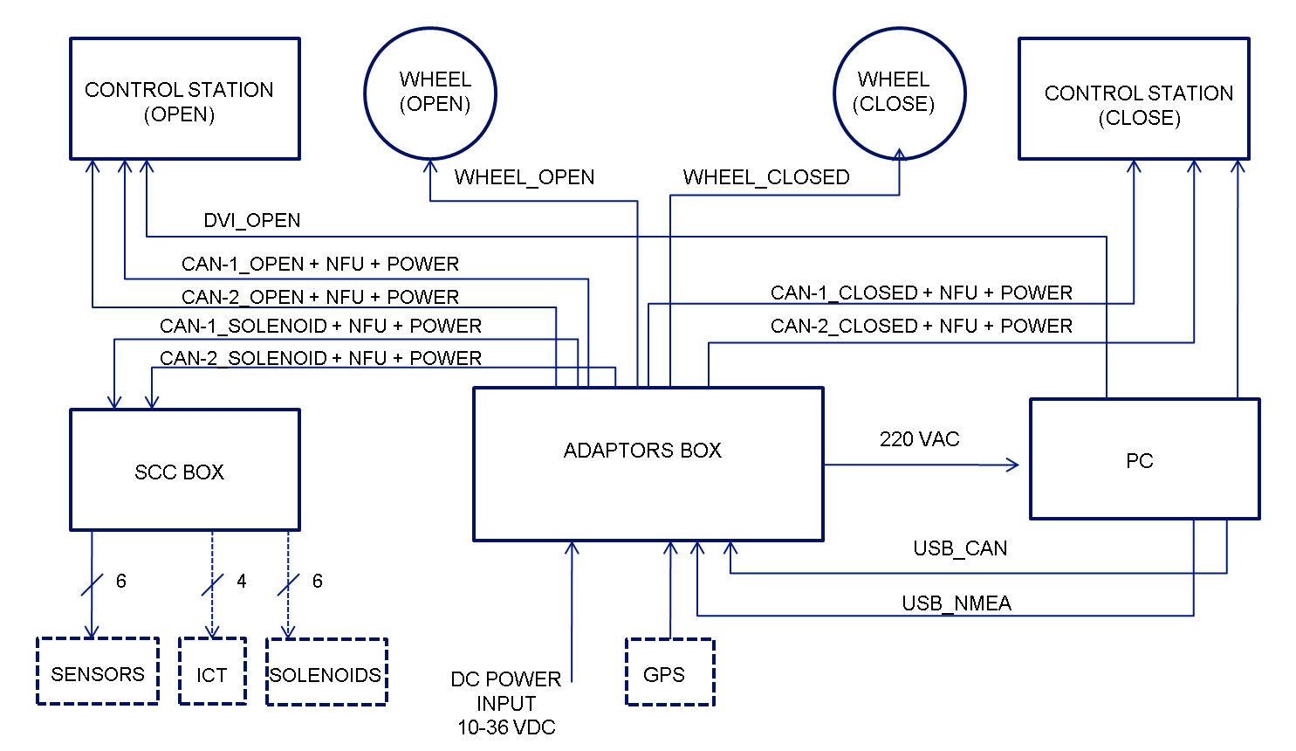

This diagram is described about the component of ACS System.

* USB_CAN and USB_NMEA use for connecting PC and ADAPTORS BOX.
* CAN-1 and CAN-2 used for connecting control station and ACS Application.
* CAN-1 SOLENOID and CAN-2 SOLENOID use for transfer control signal from Adaptors Box to SCC BOX.
* GPS connect to Adaptors Box for feed location and application received location data through adaptor box (You have to configure port by selecting dip switches inside adaptor box)

***Note: -***

Here use 2 CAN bus one work as active and other one use as redundancy.

# Background:

P444 Series of Super Dvora MK III joined SLN fleet on 01st April 2010. Currently SLN fleet has 6 no’s of Super Dvoras .

|  |  |
| --- | --- |
| Name | Date of Join to SLN fleet |
| P4442 | 01st April 2010 |
| P4443 | 18th July 2010 |
| P4444 | 24th September 2010 |
| P4445 | 08th November 2010 |
| P4446 | 16 March 2011 |
| P4447 | 25th February 2011 |

P 4445 which joined on 08th November 2010, developed a defect in steering which non synchronizing of propeller movement with the wheel moment (Error message popped up as “System encountered an uncorrectable hardware error”)

# Advantages:

1. Reduce the maintenance cost of current ACS System.
2. Increase the stability of the system.

# Project Scope:

Design and develop ACS System using single board computer with two control panel same as existing system.

# Future Trends

By looking at previous defects and no occurrence PC is not suitable for such environment because of pitching and rolling it will effect to PC hard disk directly though it mount on shock absorber. Also PC is general purpose machine it runs other process rather than ACS application. I would like to propose following module instead of ACS PC.

# Project Phases:

1. Circuit Design for interfacing CAN bus to single board computer.
2. Interface design and development.
3. System calibration.

# Project Plan

## Item Requirement (Main Console):



### 

## System architecture:

Closed Bridge

HDMI Splitter

Open Bridge

SCC BOX

Banana PI Single board Computer

Adaptor BOX

# 

CAN BUS

# Time Schedule

# 

|  |  |  |  |  |  |  |  |  |  |  |  |  |  |  |  |
| --- | --- | --- | --- | --- | --- | --- | --- | --- | --- | --- | --- | --- | --- | --- | --- |
| **Milestone** | **Time In Months** | | | | | | | | | | | | | | |
|  | 1 | 2 | 3 | 4 | 5 | 6 | 7 | 8 | 9 | 10 | 11 | 12 | 13 | 14 | 15 |
| Study CAN Signal in current system |  |  |  |  |  |  |  |  |  |  |  |  |  |  |  |
| Process control signal |  |  |  |  |  |  |  |  |  |  |  |  |  |  |  |
| Design circuit and developing CAN controller |  |  |  |  |  |  |  |  |  |  |  |  |  |  |  |
| Design UI and testing system |  |  |  |  |  |  |  |  |  |  |  |  |  |  |  |